Design and Implementation of a 4-Way Traffic Signal Control System Using Arduino UNO
Course: Embedded Systems (Assignment No: 01)
1. Introduction
Urbanization and the rapid increase in the number of vehicles on the road have made traffic congestion one of the most critical challenges facing modern city planning. Traffic management systems used at road intersections are designed to facilitate the safe, orderly, and efficient movement of both vehicular and pedestrian traffic. Traditional traffic signals function by allocating the right-of-way to specific movements at an intersection using a predetermined sequence of light indicators.
The implementation of an automated intersection control system serves to minimize conflict points where accidents are highly probable. By introducing an embedded microcontroller framework to regulate these intersections, engineering students can analyze the real-time constraints, logic state allocations, and electrical parameters governing daily transportation infrastructure. This report details the design, algorithmic logic, program development, and future enhancement paths of a 4-way traffic junction managed via an Arduino UNO platform.

2. Literature Study
2.1 Working Principle of Intersection Management
Traffic control systems operate on the principle of time-division multiplexing applied to spatial coordinates. The intersection is divided into discrete phases, where a phase represents a unique combination of traffic movements that receive the right-of-way simultaneously. The primary goal is to ensure that conflicting traffic streams—such as vehicles turning right across oncoming traffic or cross-street movements—are never allowed to enter the intersection at the same time.
2.2 Significance of Signal Colors
The signaling sequence utilizes a universal, standardized color code to convey precise behavioral instructions to motorists:
- Red Signal: Indicates a mandatory stop condition. The right-of-way is entirely revoked for the designated lane, and vehicles must remain stationary behind the stop line.
- Yellow Signal: Serves as a transitional phase. It warns drivers that the green interval is terminating and the signal is about to turn red. This interval is critical for preventing rear-end collisions by allowing vehicles already inside the intersection to clear it safely (solving the "dilemma zone" problem).
- Green Signal: Indicates that the right-of-way has been granted. Vehicles are permitted to proceed straight or turn, subject to safety overrules and pedestrian clearance.
3. Hardware Design
3.1 Components List
To construct the 4-way intersection system on breadboards or within an emulation environment, the following hardware components are required:
- Arduino UNO Microcontroller Board (1 unit): The central processing unit featuring the ATmega328P microcontroller to execute the control sequence.
- High-Brightness LEDs (12 units): Divided into 4 groups of 3 (Red, Yellow, Green) representing the North, East, South, and West traffic lanes.
- Current Limiting Resistors (12 units - $220\ \Omega$): Connected in series with each LED anode to prevent excessive current draw from the digital I/O pins, protecting the LEDs and the microcontroller from thermal damage.
- Breadboard & Jumper Wires: For establishing robust electrical paths between the Arduino, resistors, and LEDs.
- USB Type-A to Type-B Cable: For firmware flashing and powering the board from a computer workstation.

3.2 Block Diagram
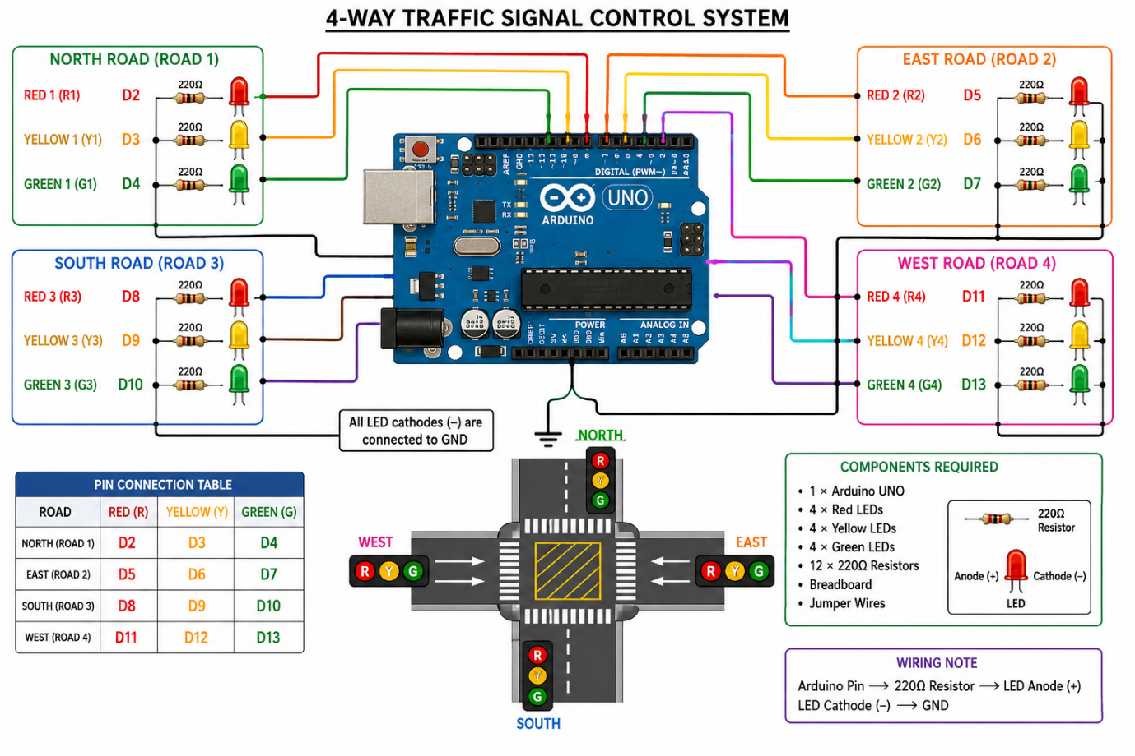

3.3 Pin Allocation Table
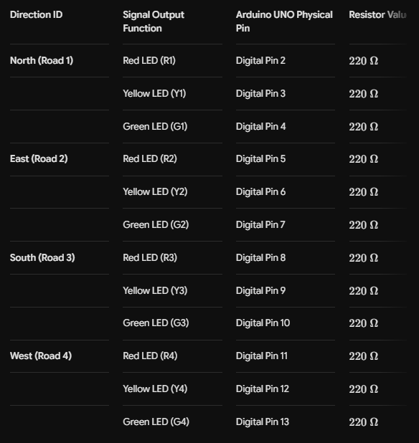

3.4 Circuit Diagram
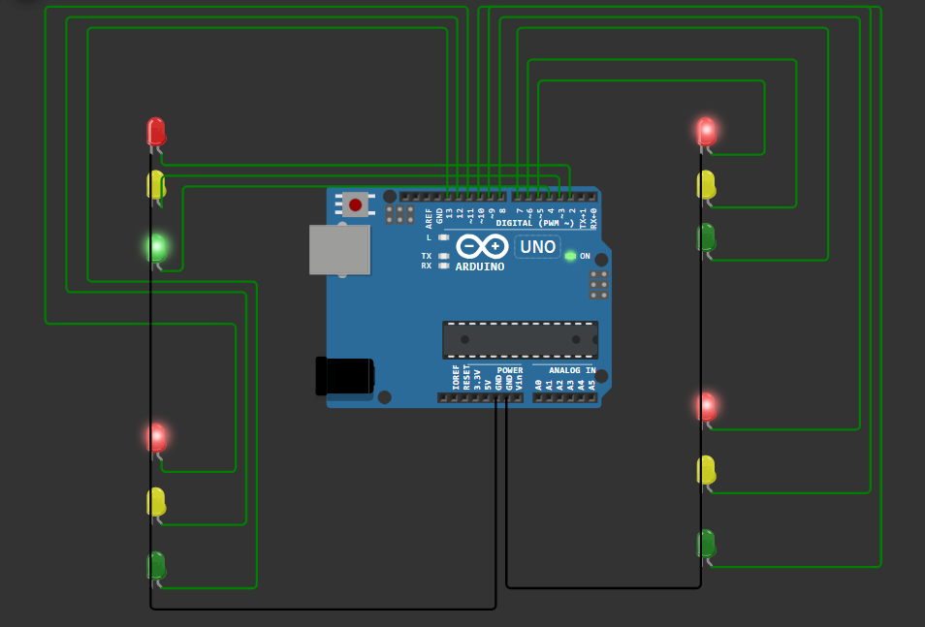
3.5 video link
https://drive.google.com/file/d/16c9OO7ng2aiYvzqAMbV2bLejNkTPfPbd/view?usp=sharing

4. Algorithm and Logic Development
  - Algorithmic Control Flow
Initialization: Configure digital I/O pins 2 through 13 as OUTPUT nodes. Force all Red signal pins (R1, R2, R3, R4) to HIGH to establish a safe default configuration. Turn off all Yellow and Green LEDs.
- North Phase:
  - Switch off North Red (R1); switch on North Green (G1). Maintain state for 10,000 ms.
  - Switch off North Green (G1); switch on North Yellow (Y1). Maintain state for 3,000 ms.
  - Switch off North Yellow (Y1); switch on North Red (R1).
- East Phase:
  - Switch off East Red (R2); switch on East Green (G2). Maintain state for 10,000 ms.
  - Switch off East Green (G2); switch on East Yellow (Y2). Maintain state for 3,000 ms.
  - Switch off East Yellow (Y2); switch on East Red (R2).
- South Phase:
  - Switch off South Red (R3); switch on South Green (G3). Maintain state for 10,000 ms.
  - Switch off South Green (G3); switch on South Yellow (Y3). Maintain state for 3,000 ms.
  - Switch off South Yellow (Y3); switch on South Red (R3).
- West Phase:
  - Switch off West Red (R4); switch on West Green (G4). Maintain state for 10,000 ms.
  - Switch off West Green (G4); switch on West Yellow (Y4). Maintain state for 3,000 ms.
  - Switch off West Yellow (Y4); switch on West Red (R4).
- Loop Execution: Repeat from Step 2 infinitely.

4.2 System Flowchart
│ START │
│
▼
│ Initialize Arduino Pins │
│ Set All Reds = ON │
│ Set All Y/G = OFF │
│
│ North Road Green ON │
│ Others Red ON │
│ Wait 10 sec │
│
▼
│ North Yellow ON │
│ Wait 3 sec │
│
▼
│ East Road Green ON │
│ Others Red ON │
│ Wait 10 sec │
│
▼
│ East Yellow ON │
│ Wait 3 sec │
│
▼
│ South Road Green ON │
│ Others Red ON │
│ Wait 10 sec │
│
▼
│ South Yellow ON │
│ Wait 3 sec │
│
▼
│ West Road Green ON │
│ Others Red ON │
│ Wait 10 sec │
│
▼
│ West Yellow ON │
│ Wait 3 sec │
│
▼
│ Repeat Cycle Forever │
│
└──────────────► Back to
North Road

4.3 Logic Segregation & Safety Fail-Safe
To avoid catastrophic intersection collisions, the logic follows a strict exclusionary lock pattern. The software architecture prevents a direction from executing its Green or Yellow phase until the preceding direction has closed its active phase and turned its Red LED HIGH. By writing a baseline initialization function (setAllRed()), the system ensures that if the loop breaks or restarts, no two roads can ever display green lights simultaneously.

5. Arduino Program Development
// North Direction Pins (Road 1)
const int R1 = 2;
const int Y1 = 3;
const int G1 = 4;

// East Direction Pins (Road 2)
const int R2 = 5;
const int Y2 = 6;
const int G2 = 7;

// South Direction Pins (Road 3)
const int R3 = 8;
const int Y3 = 9;
const int G3 = 10;

// West Direction Pins (Road 4)
const int R4 = 11;
const int Y4 = 12;
const int G4 = 13;

const unsigned long GREEN_INTERVAL = 5000;
const unsigned long YELLOW_INTERVAL = 1500;

void setup() {
for (int electricalPin = 2; electricalPin <= 13; electricalPin++) {
pinMode(electricalPin, OUTPUT);
}
initializeSafeState();
}

void loop() {
// PHASE 1: North Road (Road 1)
digitalWrite(R1, LOW);
digitalWrite(G1, HIGH);
delay(GREEN_INTERVAL);

digitalWrite(G1, LOW);
digitalWrite(Y1, HIGH);
delay(YELLOW_INTERVAL);

digitalWrite(Y1, LOW);
digitalWrite(R1, HIGH);

// PHASE 2: East Road (Road 2)
digitalWrite(R2, LOW);
digitalWrite(G2, HIGH);
delay(GREEN_INTERVAL);

digitalWrite(G2, LOW);
digitalWrite(Y2, HIGH);
delay(YELLOW_INTERVAL);

digitalWrite(Y2, LOW);
digitalWrite(R2, HIGH);

// PHASE 3: South Road (Road 3)
digitalWrite(R3, LOW);
digitalWrite(G3, HIGH);
delay(GREEN_INTERVAL);

digitalWrite(G3, LOW);
digitalWrite(Y3, HIGH);
delay(YELLOW_INTERVAL);

digitalWrite(Y3, LOW);
digitalWrite(R3, HIGH);

// PHASE 4: West Road (Road 4)
digitalWrite(R4, LOW);
digitalWrite(G4, HIGH);
delay(GREEN_INTERVAL);

digitalWrite(G4, LOW);
digitalWrite(Y4, HIGH);
delay(YELLOW_INTERVAL);

digitalWrite(Y4, LOW);
digitalWrite(R4, HIGH);
}

void initializeSafeState() {
digitalWrite(R1, HIGH); digitalWrite(Y1, LOW); digitalWrite(G1, LOW);
digitalWrite(R2, HIGH); digitalWrite(Y2, LOW); digitalWrite(G2, LOW);
digitalWrite(R3, HIGH); digitalWrite(Y3, LOW); digitalWrite(G3, LOW);
digitalWrite(R4, HIGH); digitalWrite(Y4, LOW); digitalWrite(G4, LOW);
}

6. Future Design Enhancements
6.1 Sensor-Based Adaptive Automation
To optimize traffic flow, the fixed-time framework can be upgraded to an intelligent, adaptive platform. By placing ultrasonic sensors or induction loop detectors across each approach road, the system can measure real-time vehicle density. Roads with higher vehicle queues can automatically receive extended green windows, while empty lanes can be skipped to drastically minimize intersection wait times.

6.2 Integrated Pedestrian Crossing Modes
To protect pedestrians, a dedicated crosswalk button system can be integrated. Pedestrians can press a push-button to send an external hardware interrupt request (using Arduino Pins D2 or D3). This override would turn all 4 vehicular paths red simultaneously, activating a pedestrian walk signal to allow safe crossing.

6.3 IoT Remote Monitoring Infrastructure
Integrating an ESP32 or ESP8266 controller allows the system to connect to the Internet of Things (IoT). It can transmit live intersection status updates, congestion indexes, and hardware failure alerts to a central database via MQTT or HTTP protocols. This allows emergency vehicles (like ambulances) to send remote override commands to clear traffic paths along their routes.

6.4 AI-Driven Traffic Management
By replacing standard sensors with camera nodes connected to Edge-AI computing processors, the intersection can run real-time object detection models (such as YOLO). This allows the system to differentiate between emergency vehicles, heavy transport trucks, and standard passenger vehicles, dynamically adjusting traffic flows to maximize city-wide logistical efficiency.

7. Conclusion
This assignment successfully validates the design, logic development, and implementation of a 4-Way Traffic Signal Control System on an Arduino UNO platform. The system successfully enforces mutual exclusion logic to ensure that only one road receives a green light at a time. While fixed-time implementations are incredibly reliable and cost-effective for static environments, integrating IoT and adaptive sensors is a necessary step toward building scalable, responsive smart city infrastructure.

